# Task 1

1.

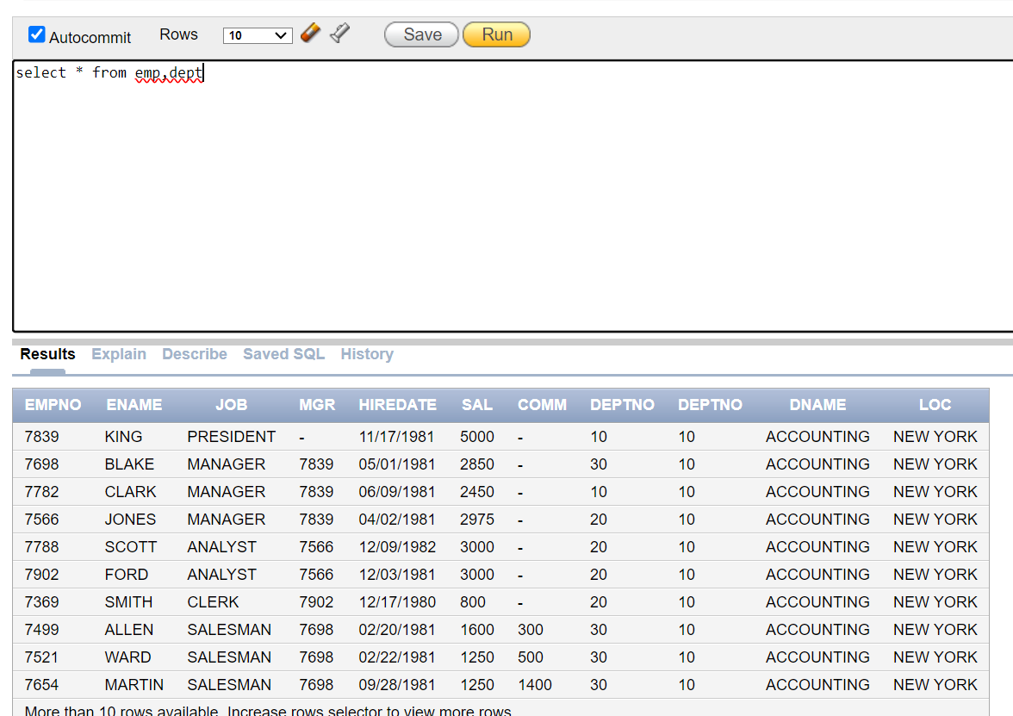

2.

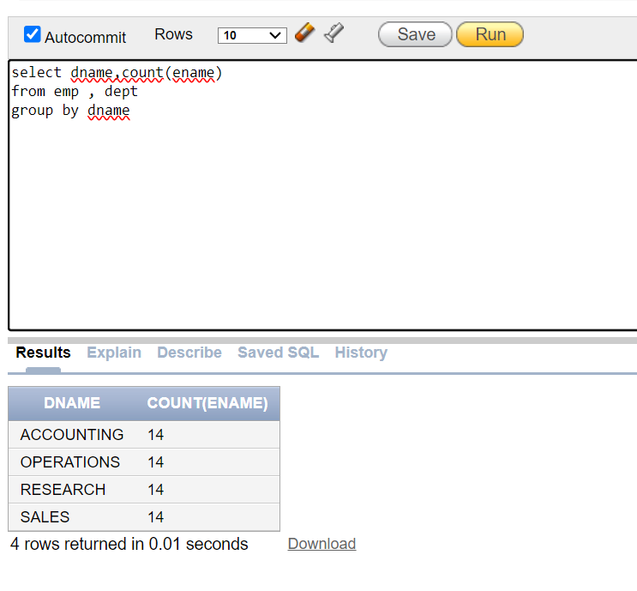

3.

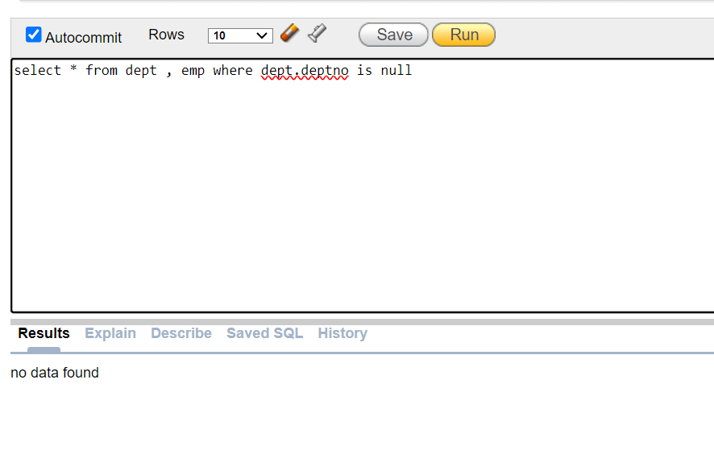

4.

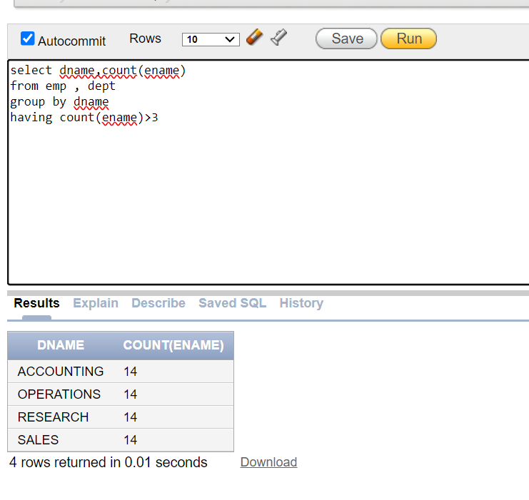

5.

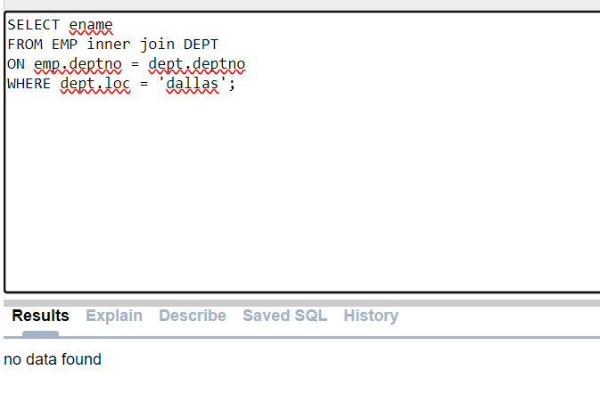

6.

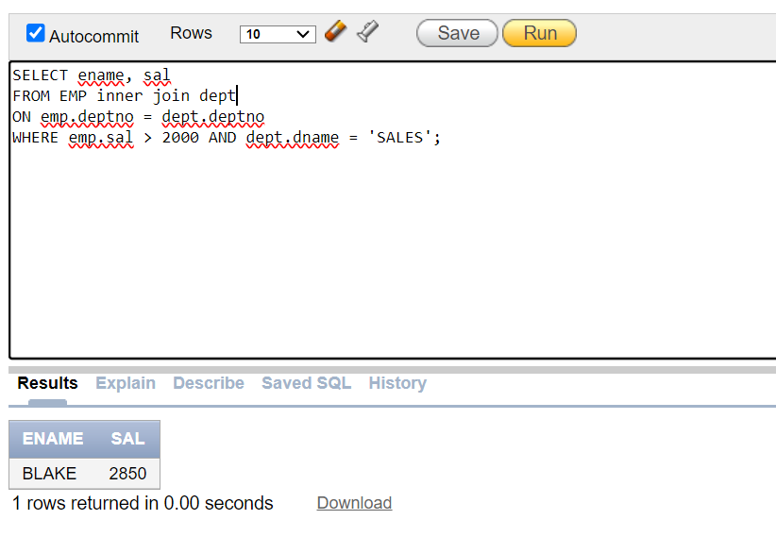

7.

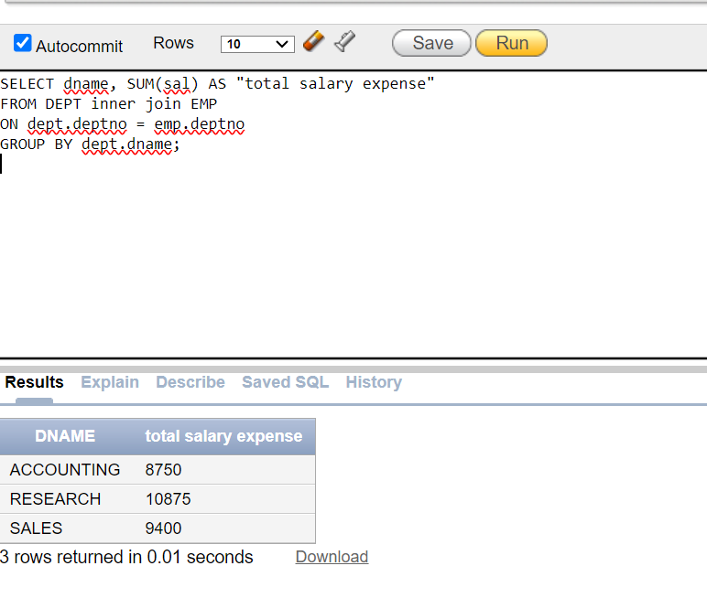

8.

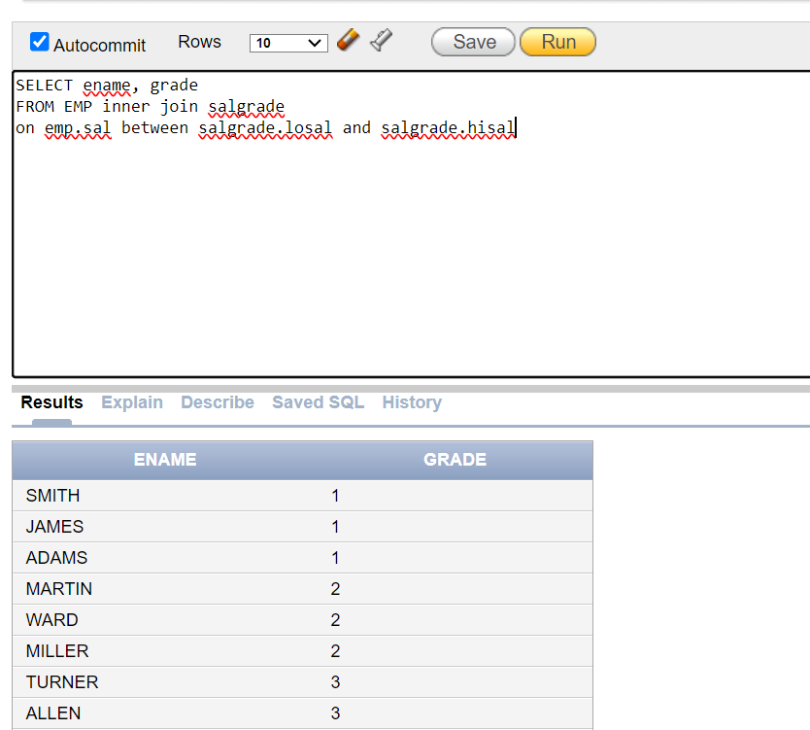

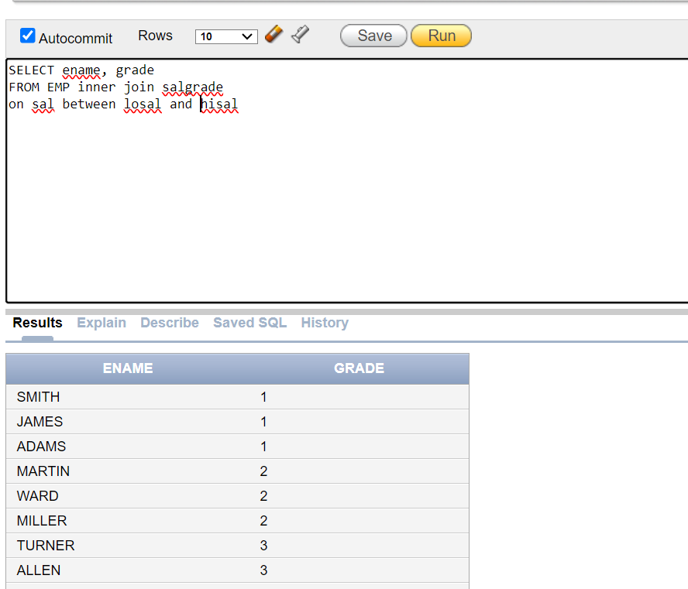

9.

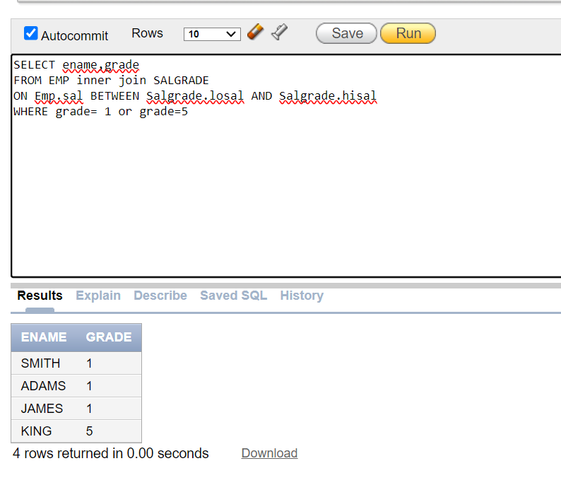

10.

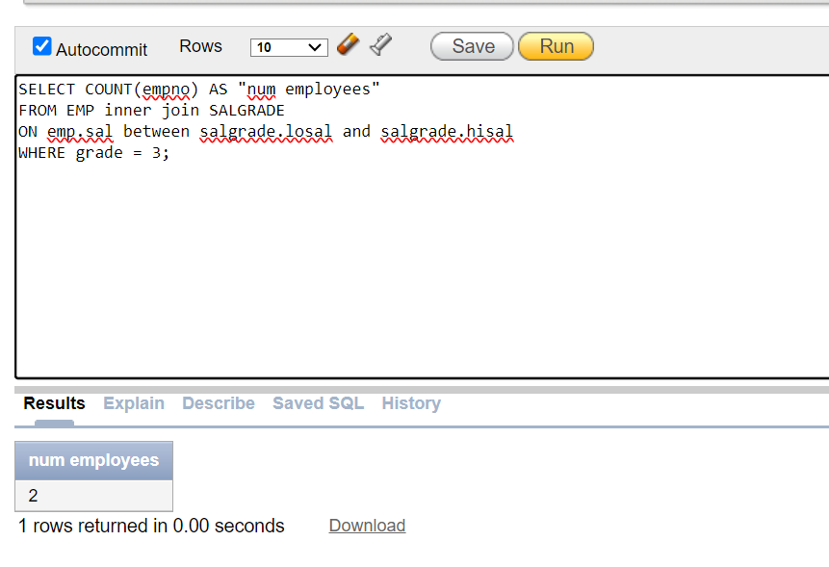

# Task2

2.

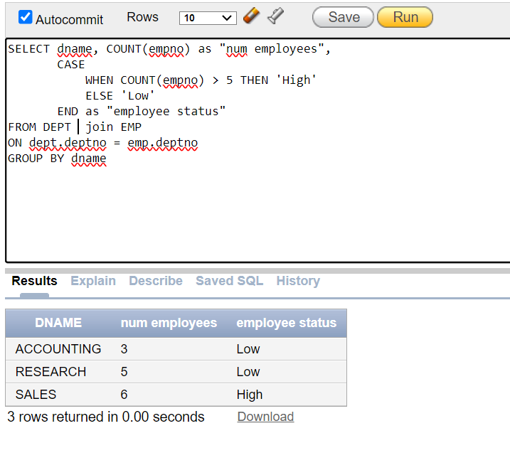

3.

4.

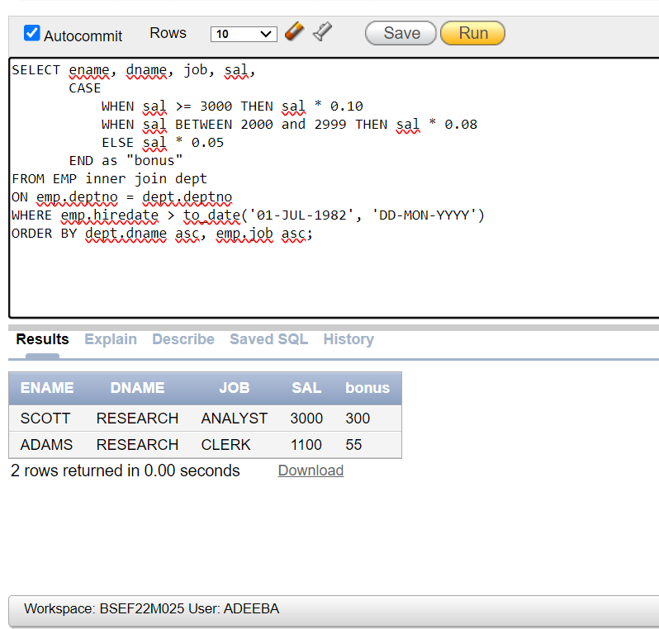

5.

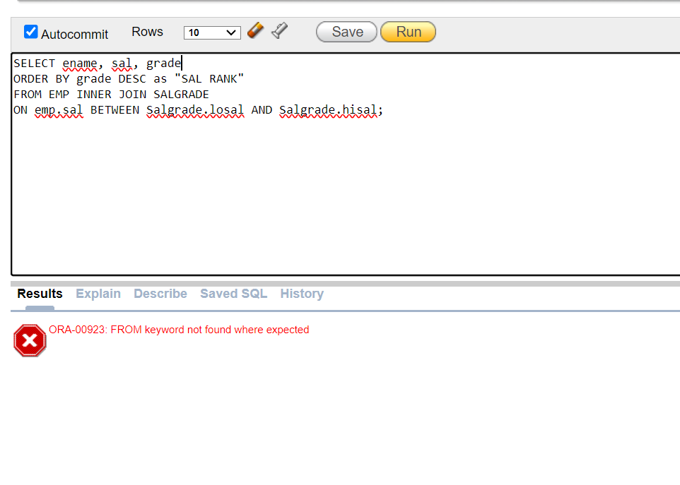

# Task 3

1.

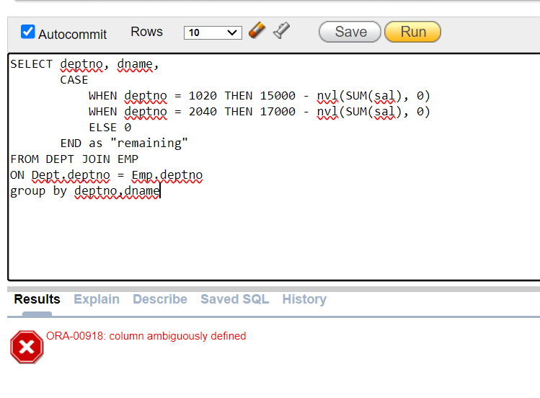

2.

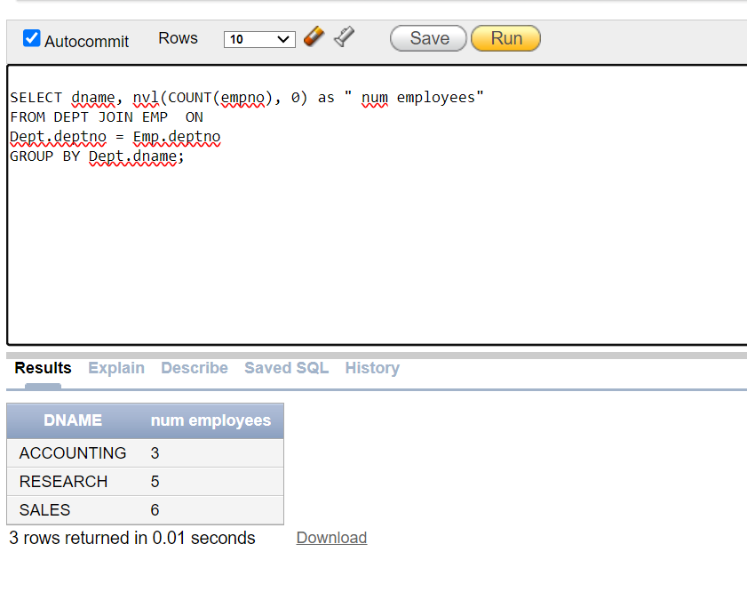

3.

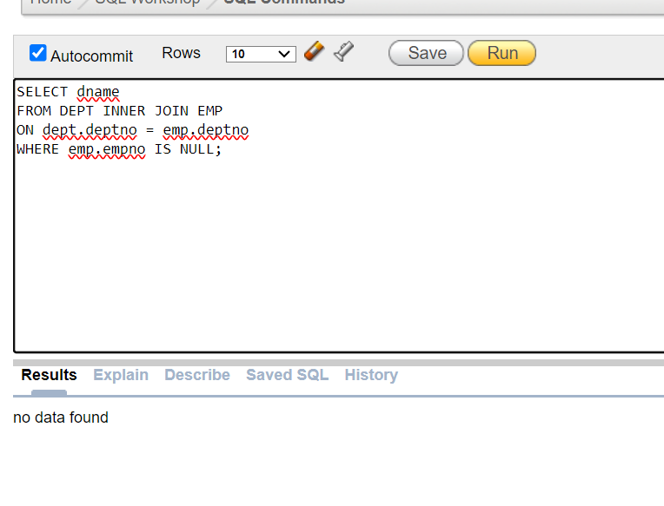

4.

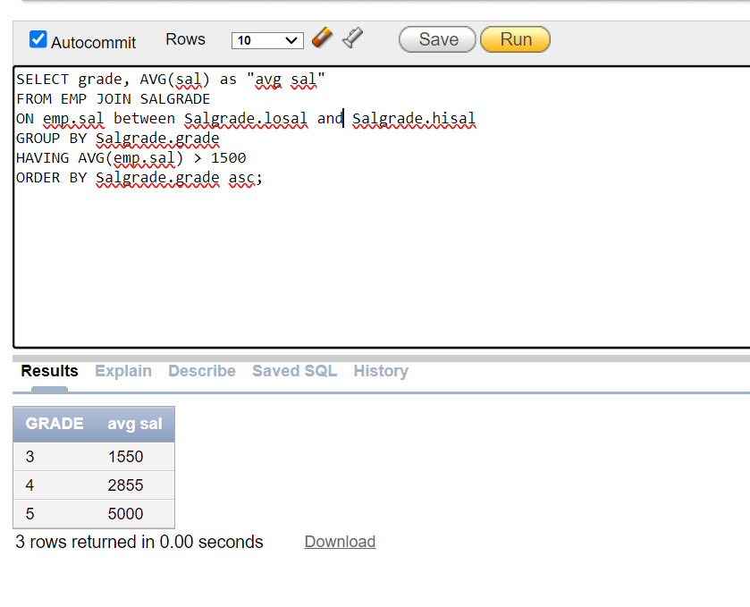

5.

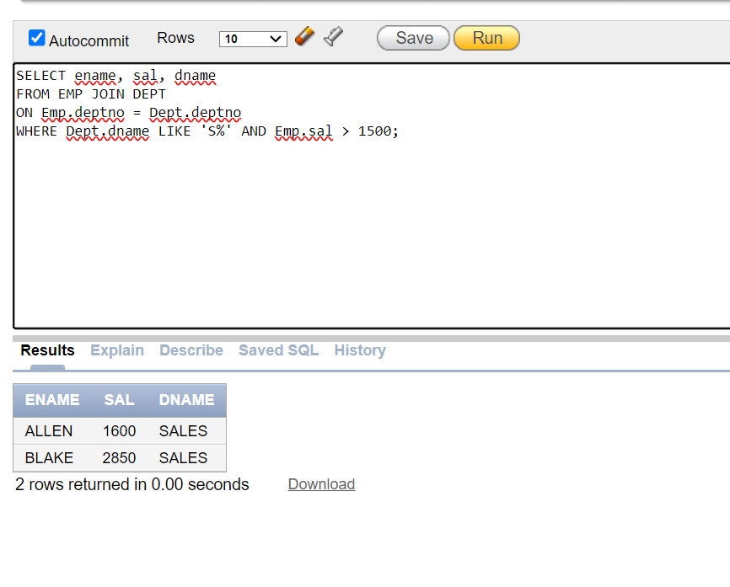

6.

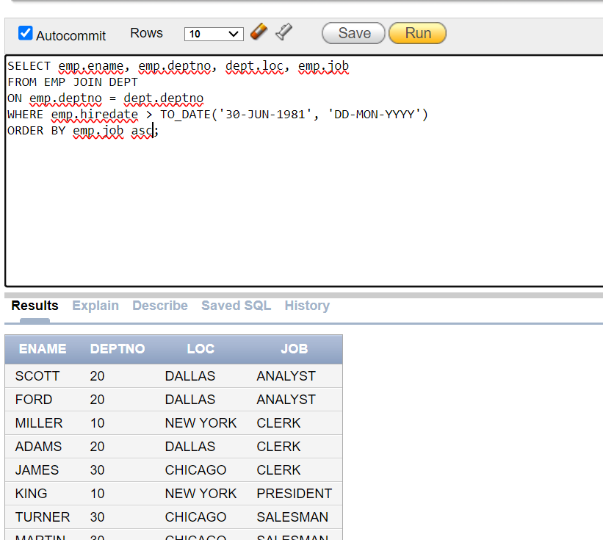

7.

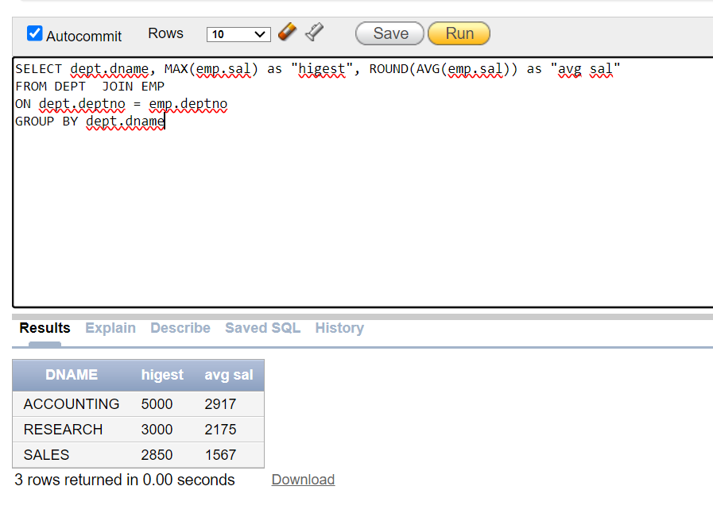

8.

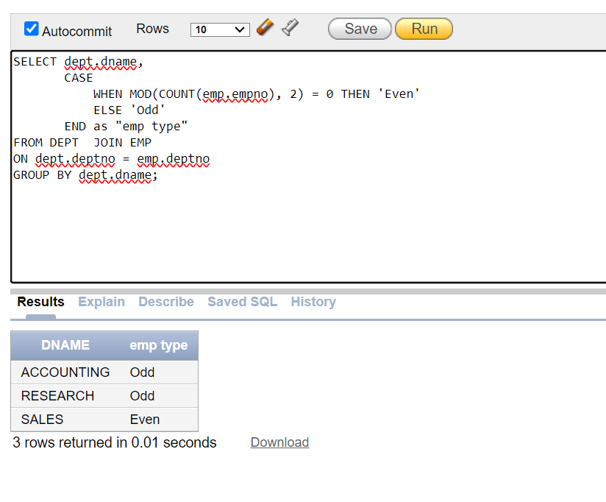

9.

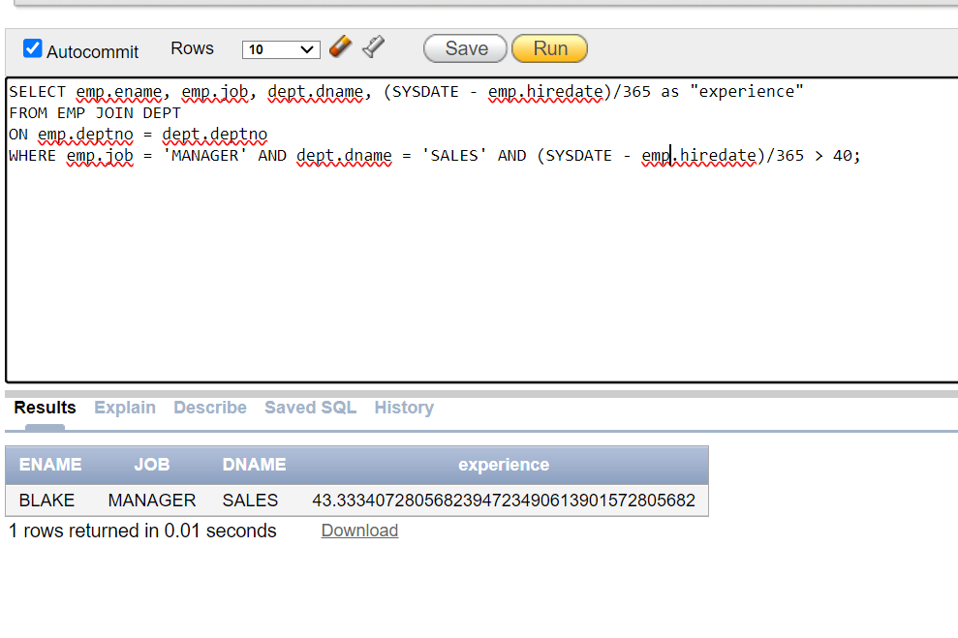

10.

Task 01: Display the manager name, manager number, and salary of the lowest-paid employee for the manager.

sql

Copy code

SELECT m.ename AS manager_name,

m.empno AS manager_number,

MIN(e.sal) AS lowest_salary

FROM emp e

JOIN emp m ON e.mgr = m.empno

GROUP BY m.ename, m.empno;

Task 02: Retrieve a list of employees who have the same salary grade as their managers.

sql

Copy code

SELECT e.ename AS employee_name,

sg_e.grade AS employee_grade

FROM emp e

JOIN emp m ON e.mgr = m.empno

JOIN salgrade sg_e ON e.sal BETWEEN sg_e.losal AND sg_e.hisal

JOIN salgrade sg_m ON m.sal BETWEEN sg_m.losal AND sg_m.hisal

WHERE sg_e.grade = sg_m.grade;

Task 03: List employee names (ENAMES) and the count of employees working under each manager.

sql

Copy code

SELECT m.ename AS manager_name,

COUNT(e.empno) AS employee_count

FROM emp e

JOIN emp m ON e.mgr = m.empno

GROUP BY m.ename;

Task 04: List employee details (EMPNO, ENAME, JOB, SAL, DEPTNO) with RANK, TAX, and NET_SAL.

sql

Copy code

SELECT e.empno,

e.ename,

e.job,

e.sal,

e.deptno,

RANK() OVER (ORDER BY e.sal DESC) AS rank,

CASE

WHEN sg.grade IN (2, 3) THEN e.sal * 0.15

ELSE e.sal * 0.12

END AS tax,

e.sal - CASE

WHEN sg.grade IN (2, 3) THEN e.sal * 0.15

ELSE e.sal * 0.12

END AS net_sal

FROM emp e

JOIN salgrade sg ON e.sal BETWEEN sg.losal AND sg.hisal;

Task 05: List all employees along with their managers, managers' salaries, and managers' salary grades.

sql

Copy code

SELECT e.ename AS employee_name,

m.ename AS manager_name,

m.sal AS manager_salary,

sg.grade AS manager_salary_grade

FROM emp e

JOIN emp m ON e.mgr = m.empno

JOIN salgrade sg ON m.sal BETWEEN sg.losal AND sg.hisal;

Task 06: List all employees, their managers, departments, number of employees in the manager's department, and the average grades.

sql

Copy code

SELECT e.ename AS employee_name,

m.ename AS manager_name,

e.deptno AS department_number,

COUNT(e.empno) OVER (PARTITION BY e.mgr) AS employees_count,

AVG(sg.grade) OVER (PARTITION BY e.deptno) AS avg_grade

FROM emp e

JOIN emp m ON e.mgr = m.empno

JOIN salgrade sg ON e.sal BETWEEN sg.losal AND sg.hisal;

Task 07: List all employees who have the same first and middle name to the middle name of any other employee.

sql

Copy code

SELECT e1.empno,

e1.ename, a

e1.job

FROM emp e1

JOIN emp e2 ON e1.ename = e2.ename

AND e1.empno != e2.empno;

Task 08: Combine first and middle names and list employees such that we get the first and middle name in one combined field.

sql

Copy code

SELECT INITCAP(SUBSTR(e.ename, 1, INSTR(e.ename, ' ') - 1)) || ' ' ||

INITCAP(SUBSTR(e.ename, INSTR(e.ename, ' ') + 1)) AS full_name

FROM emp e;

Task 09: List all employees who earn Grade 2 only by the commission they earn.

sql

Copy code

SELECT e.ename,

e.sal,

e.comm

FROM emp e

JOIN salgrade sg ON e.sal BETWEEN sg.losal AND sg.hisal

WHERE sg.grade = 2

AND e.comm IS NOT NULL;

Task 10: List employees who earn 2000 more than the average salary in their department.

sql

Copy code

SELECT e.ename,

e.sal

FROM emp e

JOIN (SELECT deptno,

AVG(sal) AS avg_sal

FROM emp

GROUP BY deptno) dept_avg ON e.deptno = dept_avg.deptno

WHERE e.sal > dept_avg.avg_sal + 2000;